FACTULTY PROFILE : DEPARTMENT OF BENGALI

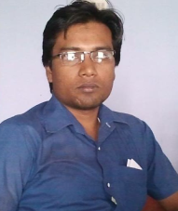

1.Name: Md Naser Ali
2. Designation: Govt. Apvt. PTT.
3. Teaching Area :Bangla Sahityer Itihaas(Adhunik Yug ),Kabyer Rupoved, kotha o probandher rup o riti, Padmanadir Manjhi,jagori uponyas, bangla sahitya bisayok prabandho,etc.
4. Research Interests: Bangla uponyase Muslim charitra.
5. Education: M.A
6. Award: Gold Medal in M. A.(1st class 1st)
7. Professional Experience: More Than 7 years(joining date - 18.08.2008)
8. Teaching Research: Nil.
Note: Attend in
1 Seminar & Workshop (Paper Publish-NIL)
Venue: SOUTH MALDA COLLEGE

